Project Details

# Tasks

* Make some data entries
* Get data entries in Freedom App

# Visuals

## Photo Details

Two photos: thumbnail and full pic.

Need a range for tablets and phone sizes

Target size: 40KB for full pic, 10 KB for thumbnail. That way a full transaction per opened activity is 50KB, while unopened activities will only burn 10 kb per activity.

# Mapping

## Location Division

Uses the Web Mercator Projection as basis. Divides the square map into boxes, and assigns each box an index, starting from the top left.

No of pixels in a row = 256*2^zoom level.

I have chosen the number of boxes to be 1024 x 1024. This gives between 40 and 25km longitude per box, moving from the equator up to ~50 degrees

The distance North-South is more confused, as the projection is only between 85 degrees North and South.

Boxes are indexed as follows:

|  |  |  |  |  |  |  |
| --- | --- | --- | --- | --- | --- | --- |
| 1 | 2 | 3 | … |  |  | 1024 |
| 1025 | 1026 | 1027 |  |  |  |  |
| 2049 | 2050 | 2051 |  |  |  |  |
| … |  |  | Z-1025 | Z-1024 | Z-1023 |  |
|  |  |  | Z-1 | Z | Z+1 |  |
|  |  |  | Z+1023 | Z+1024 | Z+1025 |  |
| 1024*1023+1 |  |  |  |  |  | 1048579 |

### Finding the index for a given location

Index can be calculated from the Web Mercator x and y coordinates as follows:

$$i=floor( \frac{x}{x_{max}}*no. of boxes per row)$$

$$j=floor\left( \frac{y}{y_{max}}*no. of boxes per row\right)*no. of boxes per row$$

$$index=i+j$$

### Finding the x and y coordinates from the longitude and latitude

The longitude and latitude should be in radians. The latitude used is the geodetic latitude.

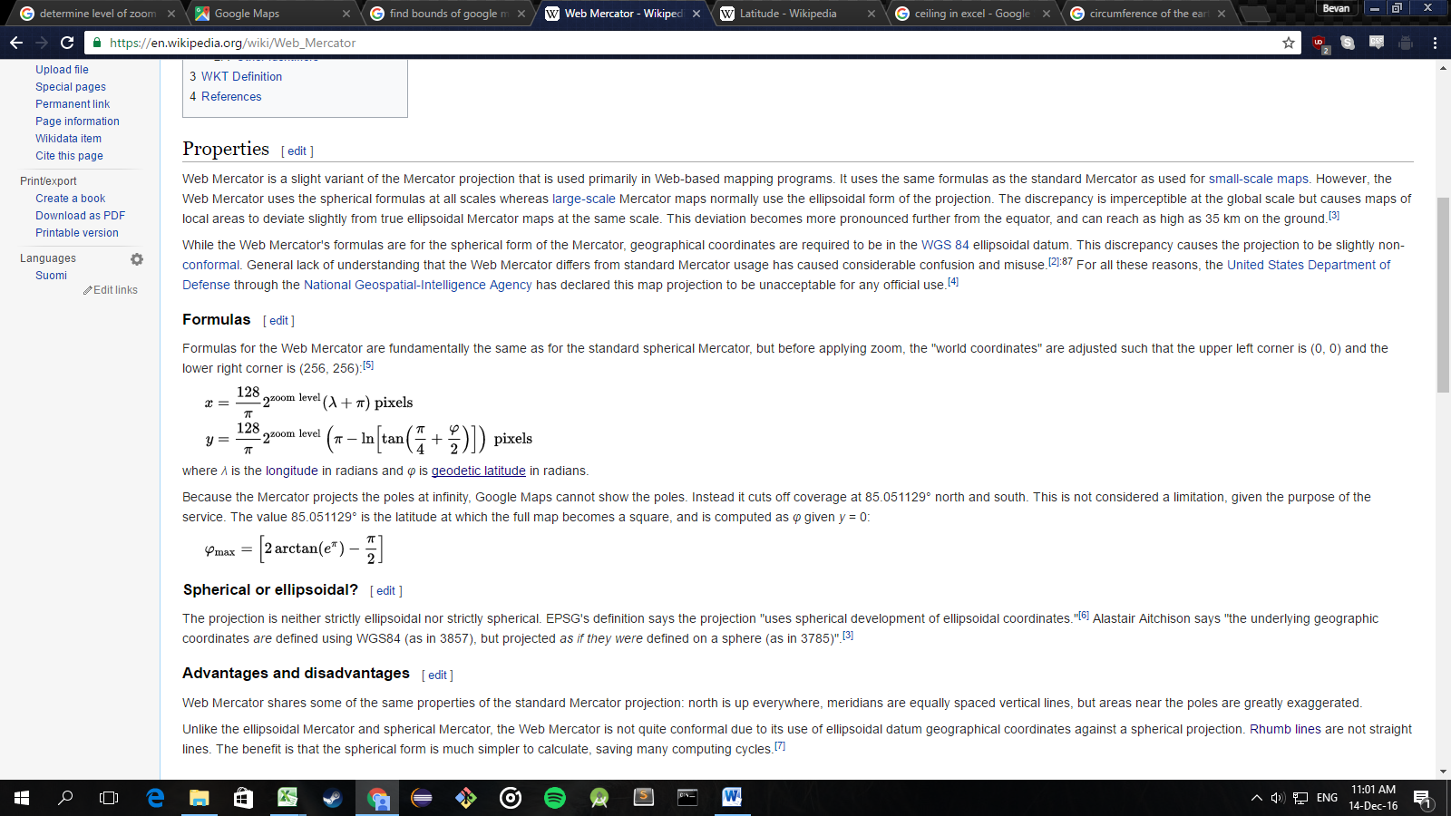

### New Zealand Bounds

|  |  |  |  |
| --- | --- | --- | --- |
|  | Longitude | Latitude | Index |
| Top Left | 166.1379 | -34.1807 | 630744 |
| Top Right | 179.4436 | -34.1807 | 630782 |
| Bottom Left | 166.1379 | -47.568 | 682968 |
| Bottom Right | 179.4436 | -47.568 | 683006 |

|  |  |  |  |  |  |  |
| --- | --- | --- | --- | --- | --- | --- |
| 630744 | … |  |  |  |  | 630782 |
| … |  |  |  |  |  |  |
|  |  |  |  |  |  |  |
|  |  |  |  |  |  |  |
|  |  |  |  |  |  |  |
|  |  |  |  |  |  |  |
| 682968 |  |  |  |  |  | 683006 |

# ID System

Web Mercator latitude and longitude, with 3 letter country code first (ISO 3166-1 alpha-3).

CCCSYYY.YYYYYYSZZZ.ZZZZZZ

CCC – three letter country code

S - sign. Either “-“ or “0”

YYY.YYYYYY – latitude

ZZZ.ZZZZZZ - longitude

Latitude and longitude are truncated to 6 decimal places. This is a granularity of 10cm at the equator.

# Uploader App

Need to add an Edit Activity option to correct mistakes.

Add a “recently submitted” view

Add “remove a submission” option

# Data For Each Entry

Country Code

Longitude

Latitude

Index

Title

Description

Address

Rating

Tag1

Tag2

Tag3